Ulric Aird

VLAN Assignment

For this assignment, I learned how VLAN and Interconnectivity work. As I gear towards learning how devices communicate with each other, this assignment showed me a whole new way on how devices communicate with each other.

First off, I inserted 2 routers, 2 switches and 4 computers for each switch. I then proceeded to configure the router with the various IP addresses and subnet mask as stated in the instructions. This is where this gets tricky. (I’m using Router PT model) Under “Serial0/1”, I configured the IP Address to be “10.0.0.1” and the other router as “10.0.0.2”. I then went to the Static menu under the config tab, and I created an interconnecting gateway. In the network text field, in Router A, I input “192.168.2.0”, with the subnet mask being “255.255.255.0” and the next hop is “10.0.0.2” since we are communicating with the other router. In Router B, in the network text field, I input “192.168.1.0” with the subnet mask being “255.255.255.0” and the network hop is “10.0.0.1”. Then I added this to the network address field. This part was done. I then proceeded to configure the first 4 computers with the IPv4 address being “192.168.1.[number here]”, and the other 4 computers with the IPv4 address being “192.168.2.[number here]”. I then proceeded to send a PDU from one device to another. It failed on the first try but when I tried again, it said successful.

This experience has been very great for me since I am learning how routers and devices communicate with each other and hope to apply this knowledge I learnt into the real world.

List of Devices

|  |  |  |  |
| --- | --- | --- | --- |
| Device Name | IPv4 Address | Subnet Mask | Default Gateway |
| Router A | 192.168.1.1 | 255.255.255.0 | 192.168.1.1 |
| PC 1 | 192.168.1.2 | 255.255.255.0 | 192.168.1.1 |
| PC 2 | 192.168.1.3 | 255.255.255.0 | 192.168.1.1 |
| PC 3 | 192.168.1.4 | 255.255.255.0 | 192.168.1.1 |
| PC 4 | 192.168.1.5 | 255.255.255.0 | 192.168.1.1 |
| Router B | 192.168.2.1 | 255.255.255.0 | 192.168.2.1 |
| PC 5 | 192.168.2.2 | 255.255.255.0 | 192.168.2.1 |
| PC 6 | 192.168.2.3 | 255.255.255.0 | 192.168.2.1 |
| PC 7 | 192.168.2.4 | 255.255.255.0 | 192.168.2.1 |
| PC 8 | 192.168.2.5 | 255.255.255.0 | 192.168.2.1 |

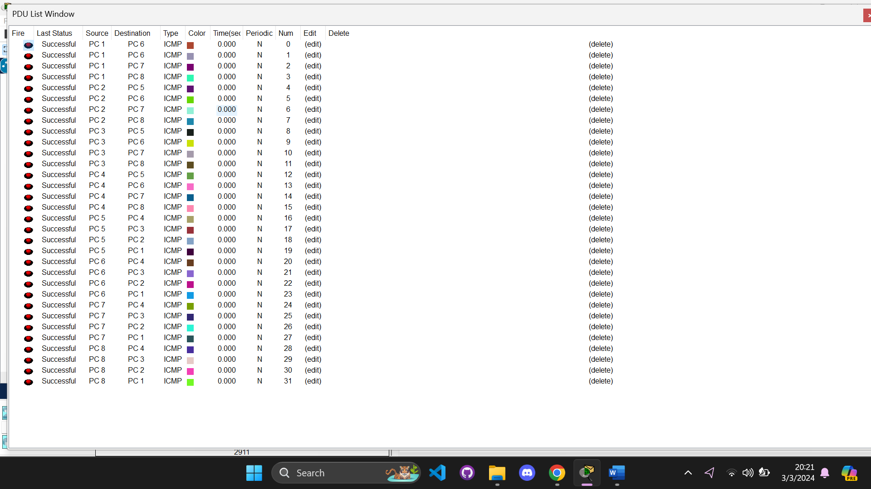PDU Test